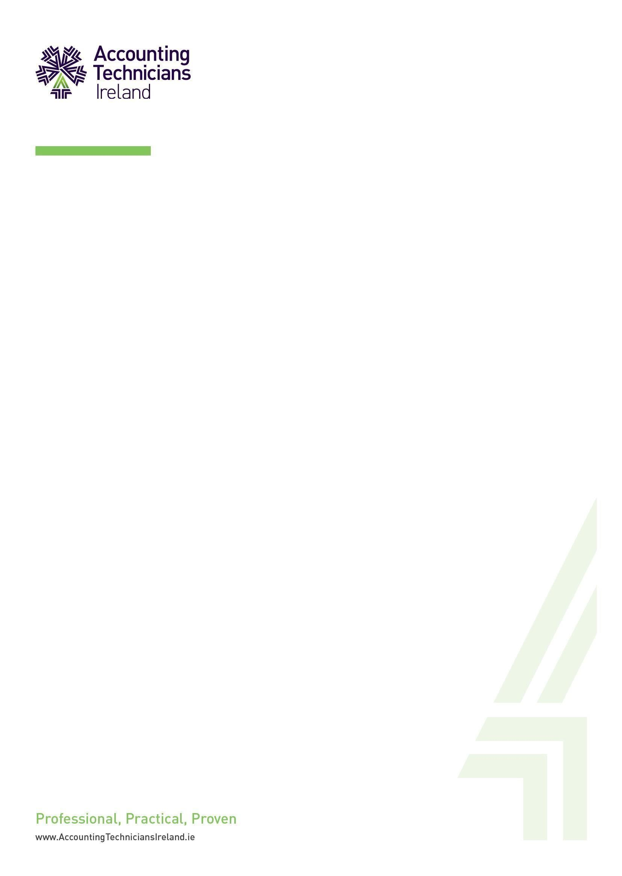

**ATI FOR031**

**Reasonable Accommodation Consent Form**

**2024/2025**

**ATI Reasonable Accommodation Consent Form**

# Consent to Disclose and Share Reasonable Accommodation Information

Accounting Technicians Ireland is committed to ensuring that students with a disability have as complete and equitable access to all resources available that can reasonably be provided. ATI has adopted a Reasonable Accommodation Policy for students requesting reasonable accommodation. This policy is in accordance with the Disability Act 2005 and the Equal Status Acts 2000 (as amended). Students requesting Reasonable Accommodation are encouraged to register with the Assessment Department to participate fully in the examination session. This Consent to Disclose and Share Reasonable Accommodation Information form applies to all students requesting Reasonable Accommodation for the examinations.

# ATI Policy on confidentiality for students with disabilities

ATI encourages students requesting Reasonable Accommodation to disclose information on their disability/specific learning difficulty to the Assessment Team before they apply to ATI by the end of November each year. Such disclosure is encouraged so that the Assessment Team can work with the student in ensuring that any reasonable accommodation required is identified and facilitated in consultation with the student.

An electronic record of your contact with us is held securely in accordance with the General Data

Protection Regulation (GDPR), and information provided to the Assessment Team is regarded as ‘sensitive personal data’. The information may also be used for statistical and monitoring purposes without your identity being revealed.

Any documentation or information presented in disclosing a disability is held by the Assessment Team, and specific medical or other documentation will not be disclosed to any third party, except where necessary to provide reasonable accommodations. Where a student requests and is granted any form of reasonable accommodation, such as extra time in exams, the Assessment Team will, in consultation with the student, disclose relevant information to the individuals responsible for providing or facilitating students in accessing such accommodations.

In such instances, only information relevant to the particular situation will be disclosed. Where academic staff contact the Assessment Team for advice regarding individual students, staff will be informed that it is necessary to obtain the permission of the student before doing so.

# Why we hold your data

In order to assess whether it is appropriate to make these reasonable accommodations and/or the nature of the accommodations to be made, the **Assessment Team** may:

• Collect and process the following types of data:

a. Personal/identification details (such as name and ATI Registration number)

b. Course details

1. Information you supply about your disability/medical condition (medical evidence,

Educational Impact Assessment, Educational psychologist assessment reports

1. Other relevant correspondence and reports

• Share some information* about your disability, on a need-to-know basis, with:

a. Relevant ATI/College Tutor staff (e.g. Course Lecturers, Compliance Officer, Invigilators to help facilitate you at the exam centre)

• Store your data securely, as follows:

1. Paper records/documents – the Assessment Team do not hold any paper documents and will give paper records back to student once scanned. Paper records posted for the attention of the Assessment Department will be scanned and shredded.
2. Electronic records: all reasonable accommodation documentation you provide is securely stored in the Assessment folder. Notes on all interactions are stored in the Assessment Department database, with access limited to authorised Assessment staff.
3. Retain your data for as long as you are a student with ATI. It will then be securely destroyed.
4. Statistical information gathered to monitor and evaluate the Disability Service will be anonymous.

Please note that if you provide this information in advance of registering with ATI and then choose to not enrol, your medical evidence will be destroyed. If you decide to study at ATI at a later date you will need to re-submit your medical evidence and consent form.

**Other students**: ATI will not disclose details of your reasonable accommodation to other students; it is your choice whether to tell others that you are accessing / receiving support.

**Parents/guardians:** Due to General Data Protection Regulations (GDPR), information about your disability and your support requirements/arrangements will not be shared or discussed with your parents/guardians without your written consent. Please note that even if such consent is provided to share or discuss, parents cannot act, or request changes, on your behalf and that you retain responsibility for engaging with the Examination Department.

**Your rights:** You may at any time request restrictions to the processing or sharing of your data by the Examination Department. However, such restrictions may adversely affect the level of support or reasonable accommodation that ATI can offer. If you have any concerns about this or would like to discuss the consequences of disclosing or withholding information, speak to the Assessment Lead.

You have the right to request access to the records held by ATI relating to you. See ATI’s Data Protection Policy here for further information, or contact the Data Protection Advisor at dp@accountingtechniciansireland.ie to ask how to make a request for your data.

**Reporting data breaches:** Under the GDPR, a breach which is reportable to the Data Protection Commissioner must be reported not later than 72 hours after awareness is made of it. All breaches or suspected breaches should therefore be reported to the Data Protection Advisor without delay for assessment.

**Disclosures in exceptional circumstances:** ATI may, in exceptional circumstances, share some data about your disability/condition with third parties without your consent.

These circumstances are provided for, in full, under the Data Protection Act and include:

1. Emergencies, e.g., if you are unwell / injured; or at risk of injury to yourself / others.
2. To protect the vital interests of any person, including yourself.
3. Fitness to practice issues or a duty to report to a professional body (such as CORU).
4. Complaints/appeals to ATI
5. Legal situations, e.g., legal disputes/advice/proceedings, or where required by a Court of Law.
6. To law enforcement agencies, for the prevention/detection of crime or the apprehension/prosecution of an offender.

# Declaration of understanding of consent to disclose and release disability information

I request reasonable accommodations from Accounting Technicians Ireland. I understand that the ATI Assessment Team will ensure that personal data will only be used to facilitate the required and agreed levels of reasonable accommodations and supports.

**Non-disclosure of information**: I understand that not providing consent to disclose will mean that I will not be able to receive those reasonable accommodations that require disclosure of information.

I understand that my personal details and documentation will be retained as electronic files for the duration of my time as a student in Accounting Technicians Ireland. I understand that official ATI communication is via the email that I have stated at the point of registration I will check this regularly and respond accordingly.

# Name (Block Capitals)

**Signed: ___________________________**

**Dated: _______________________**